Employee’s Name: A. Amir John

Supplier Address: Cognizant Technology Solutions India Pvt Ltd

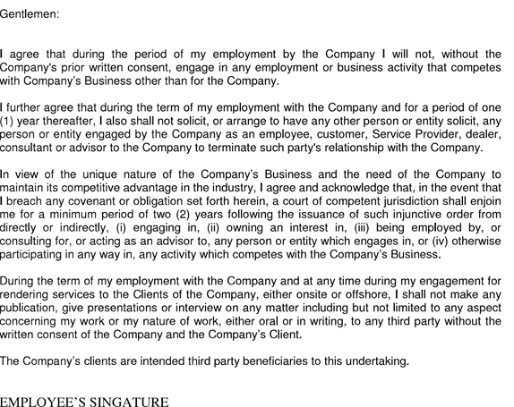

A.Amir john